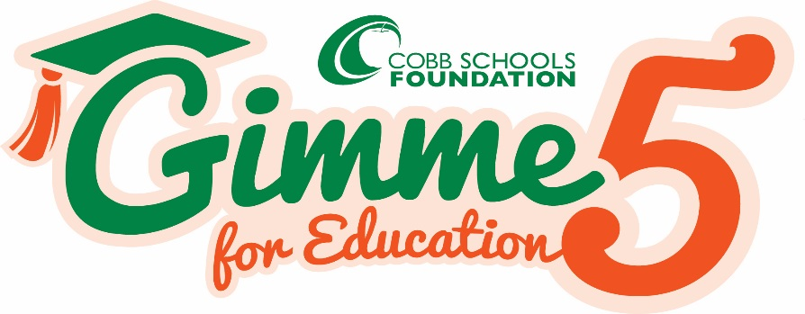
Dear Parents,

Once again, our school is participating in the “Gimme 5 for Education” campaign to raise funds for the Cobb Schools Foundation! The Cobb Schools Foundation is the only non-profit organization that supports all our schools, staff and students in the Cobb County School District. Students will be entered into a drawing to win a SPHERO ROBOT for each $5 donated!

What does the Cobb Schools Foundation do?

- Provides IMPACT Grants to our teachers, over $240,000 awarded!
- Funds ASP Scholarships for our students in need at Big Shanty, over $140,000 awarded!
- Supports the Big Shanty Foundation by managing their fund and providing resources and training throughout the year.
- Sponsors the Volunteer of the Year Luncheon.
- Sponsors college scholarships for our High Schools.
- Supports SAT Test Prep Program for High School Students
- So much more!

“Will any money I donate stay at Big Shanty School?” YES!!!

* If our school reaches $250 of donations, 20% will be given directly back to Big Shanty.
* If our school reaches $750 in donations, 50% will be given directly back to Big Shanty.

This year, the proceeds we raise at our school will benefit school needs, as directed by the Principal.

Please make a $5 tax-deductible contribution and return it to school today in the attached envelope.

Help support our schools & students! Gimme 5 for Education!

You can also donate securely online at www.cobbschoolsfoundation.org

Donations are tax-deductible. Cobb Schools Foundation Tax ID #58-2487501

