2 points  I STEM  Go to the video recording studio set up in the back of the Learning Commons and record your answer to one of these questions:  - What do you love about STEM Days?  - What did you love about STEM Night?  - What do you love about STEM Lab?  - Tell us about a cool STEM activity you have done in your class. | 2 points  Scratch Coding  Learn some basics of coding by completing the “Getting Started with Scratch” tutorial found at https://scratch.mit.edu/projects/  editor/?tip_bar=home. Take a screen shot or a photo of you with your computer screen when you finish the tutorial. You can also send the file to your teacher if you set up an account with a parent. | 15 points  Atlanta Science Festival Event  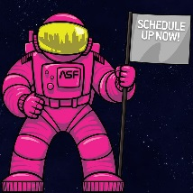  Attend an official Science Festival event and take a photo or video of yourself at the event! The Atlanta Science Festival runs from March 14-25. The full list of events can be found at http://tinyurl.com/ATLSciFe.
1 point per activity  Participate in Green Week activities.  Mon., March 13 – Make a Difference Monday (Bring a reusable water bottle)  Tues., March 14 – Wear Your Green  Weds., March 15 – Wear Your Waste (Trash collection throughout the day)  Thurs., March 16 – Wear a Hat Made of Recycled Materials  Fri., March 17 – Classroom Planting | Big Shanty Eagles love STEM, and we are excited to participate in the Atlanta Science Festival, an annual celebration of local science and technology.  Take a look at this menu of science festival activities and choose the ones that look most exciting to you. This is completely optional, but students will be able to choose a STEM project kit for every 10 points they collect! All tasks must be completed and turned in by March 30th.  View the video to learn more about this at http://tinyurl.com/BSISTEMFest. | 10 points  Design Squad Activity  Try out one of the design challenges found at http://pbskids.org/designsquad/build/.  Bring your final product to school to display in the Learning Commons. If you cannot bring your project to school because it is too large or too fragile, take a picture or video of yourself with what you made and bring the picture or share the video instead.
5 points  STEM Ernie Contest  In addition to earning 5 points toward your total, the top ten entries to this contest will earn a Scribble Bot STEM kit!  Turn Ernie Eagle into something extra special! This can be done in any way you choose. Maybe Ernie will become a robot! Maybe Ernie will get an animated face! Maybe Ernie will become a marionette! The sky is the limit, so put your creative thinking to good use! |  | 2 points  SciKu  Write your own SciKu, a haiku focused on a science, technology, engineering, or math topic. A haiku consists of three lines. The first line has 5 syllables, the second line has seven syllables, and the third line has five syllables.  Example:  Let’s all sit down at  The Periodic Table  and eat elements!  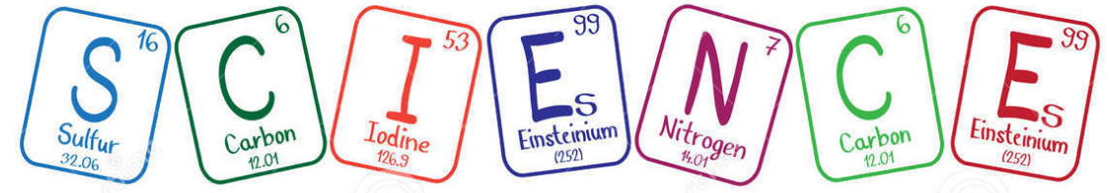
5 points  Letter Writing  Write a letter and send it to your school board member, and/or the Kennesaw City Council, and/or your state representative about why it’s important to support STEM in schools.  OR  Write a letter to the Kennesaw City Council with an idea of something Kennesaw can do to celebrate STEM! | Points Determined by Teacher  Your Own Idea!  Do you have a cool idea that isn’t listed on this sheet? Talk to your teacher about it. He/She will tell you how many points it is worth! | Total Points  Have your teacher write his/her initials over each activity you completed.  How many points did  you earn altogether?  Teacher’s Signature  Complete the prize order form on the back!
Parents, we would love for you to post your student’s work on the Big Shanty PTA Facebook page and/or Twitter using hashtags #bsieaglepride and #ATLSciFest.

Your Name
(Write your name very clearly!)
Your Teacher’s Name
How many points did you earn altogether?
For every 10 points you earned, you may choose 1 STEM kit. How many STEM kits may you choose?
(If you check too many kits, we will decide which ones you receive.)

Put a checkmark next to the kit(s) you have chosen.
Remember, you may only choose one kit for every 10 points you earned!
___ Catapult Kit
___ Balloon Car Kit | 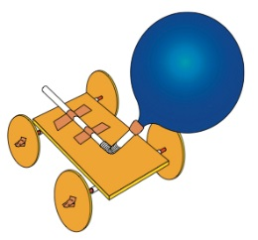
___ Marshmallow  Launcher Kit | 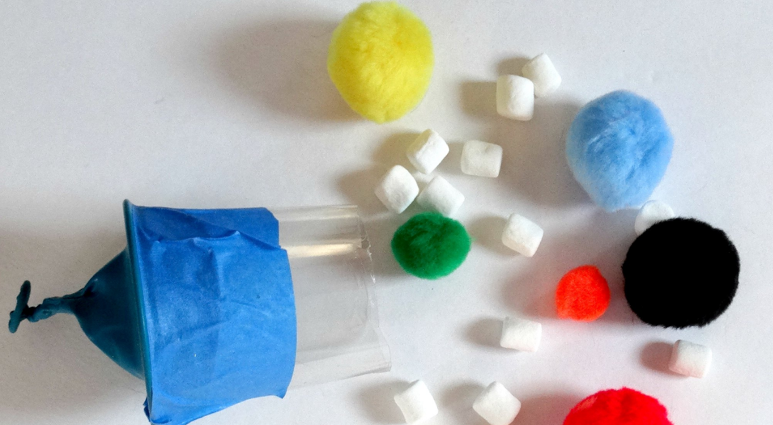
___ Small Bag of
Water Beads

